Zero Hunger - Game
For my continuous assessment in Computing and Culture I was required to create a game to promote one of the seventeen sustainable development goals. The goal I chose was the second one, ‘Zero Hunger’. My plan is to create a game in Unity that promotes learning on this goal for second level students in a way that might appeal to their demographic.
My game will be in a similar vein to ‘Subway Surfers’ or ‘Temple Run’. These are vertical scroller games where the player can move left and right and collect various items while avoiding obstacles. In my rendition of this I will be creating a game where the player will play as a farmer and collect crops that have finished growing while avoiding spoiled crops and other obstacles. I have created a mock up of what it will look like in Unity.
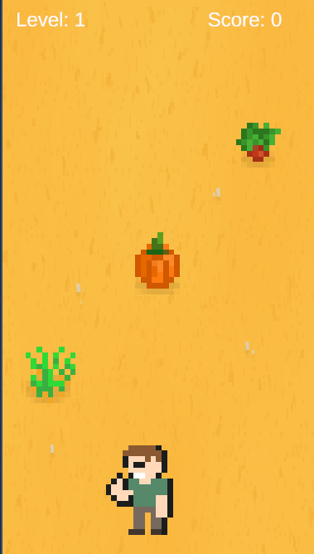
Figure 1 My game
The game will be created in Unity 6 using the 2D pipeline. The player will use controls A and D to move left and right to avoid obstacles.

